**Project Design Phase**

**Solution Architecture**

|  |  |
| --- | --- |
| Date | 27 june 2025 |
| Team ID | LTVIP2025TMID59171 |
| Project Name | HealthAI: Intelligent Healthcare Assistant Using IBM Granite |
| Maximum Marks | 4 Marks |

**Solution Architecture: Health AI**

**Definition & Purpose:**

Solution architecture in **Health AI** bridges the gap between healthcare needs and AI-driven technology. It defines the structure and components needed to develop an AI-based health assistant that can provide disease prediction, vitals monitoring, medical chat, and more.

The goals of the solution architecture in this project are to:

* Identify the **best technologies** to solve the problem of delayed and inaccessible healthcare support.
* Clearly describe the **software structure, components, and data flow** for all stakeholders.
* Break the system into phases like **Registration → Prediction → Monitoring → Reporting**.
* Provide **technical specifications** to guide development and ensure scalability, performance, and security.
* **Example - Solution Architecture Diagram:**

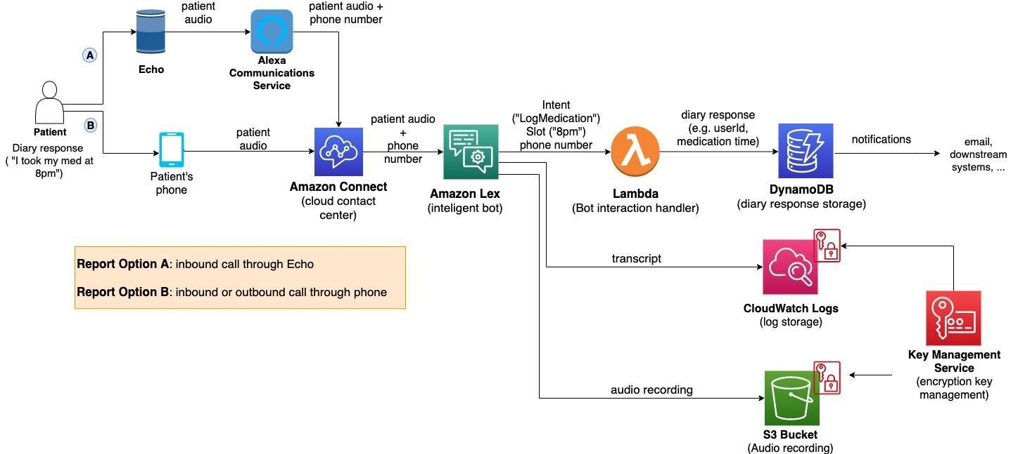

*Figure 1: Architecture and data flow of the voice patient diary sample application*

* **Reference:** [**https://aws.amazon.com/blogs/industries/voice-applications-in-clinical-research-powered-by-ai-on-aws-part-1-architecture-and-design-considerations/**](https://aws.amazon.com/blogs/industries/voice-applications-in-clinical-research-powered-by-ai-on-aws-part-1-architecture-and-design-considerations/)